

Building Plan & Completion - User Stories & Wireframes

Contents
User Stories- Building Plan Process 3
1. Add Building Plan Approval Request 3
1.1 Mock-ups 4
2. Approve/Reject Building Plan Approval Request 7
2.1 Mock-ups 8
3. View Request- Department User 10
3.1 Mock-ups 11
4. View Request- Approver 15
4.1 Mock-ups 16
5. Resubmit request for building plan request 19
5.1 Mock-ups 20
6. Cancel building plan approval request 23
6.1 Mock-ups 24
7. User Story- View Comment – Department user 24
7.1 Mock-ups 26
8. User Story- View Comment – Approver 27
8.1 Mock-ups 27
9. User Story- SMS/Email Notifications to allottee 28
10. Add Completion Certificate Request 29
10.1 Mock-ups 31
11. View Completion Certificate Request 33
11.1 Mock-ups 34
12. Generate Completion Certificate 36
12.1 Mock-ups 36
13. Generate Payment Challan 37
13.1 Mock-ups 38

User Stories- Building Plan Process

Add Building Plan Approval Request

Sprint | 5
User Story ID | 001
User Story Title | Add Building Plan Approval Request
Actors | Department user
Story | As an assistant, I want to submit building plan approval request for a property.
Pre Conditions | - User should have required access rights.
Business Criteria | - There would be only one request per property.  - Unique Request no. would be generated for each building request.  - Once, the request is submitted a notification would be sent to approver for the same.  - Auto notifications will be sent to approver with an interval of 3 days, if a request is in progress for approval for more than 3 days.  - An Email/SMS notification would be sent to allottee along with the request no.  - If a request is submitted to an approver but not actioned its status would be ‘Pending’. Approved and rejected requests would have ‘approved’ and ‘rejected’ status respectively.  - If the request is cancelled by the department user, its status would be ‘cancelled’.
Acceptance Criteria | - User would click on ‘Add Request’ option under Building Plan Approval menu and get a form which contain following fields:  - RID: drop down, mandatory  - Property Number: Label  - Scheme Name: Label  - Department: Label  - Applicant Name: Label  - Gender: Label  - Father’s/Husband Name: Label  - Property Type: Label  - Area: Label  - Floor: Label  - Plan Approval Due Date: Date picker, label  - Map Upload option (User would browse the file and upload the file.)  - Once, user validates the information he would submit request for building plan approval to manager level by clicking on ‘Submit For Approval’ button. User would get a popup to select approver name, user would select desired name and click on ‘Submit’ button.  - Alternatively, user would click on ‘Back’ button to return to Building Plan Approval menu without making any changes.  - After successful submission of request, it would be displayed in a grid on building plan page with following columns:  - Request No  - RID  - Department  - Property Number  - Request Date  - Approved Date  - Status (pending, cancelled, approved, reject)  - The options available in “Property Type” dropdown are from Property type table in database.
Field level Validation | - Map Upload File: *jpg format.

Mock-ups

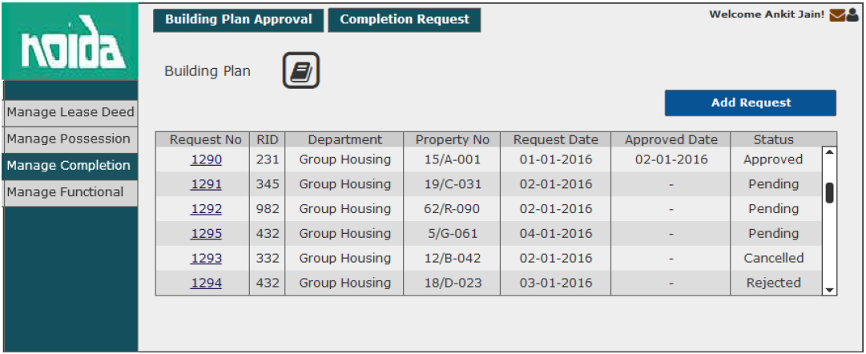
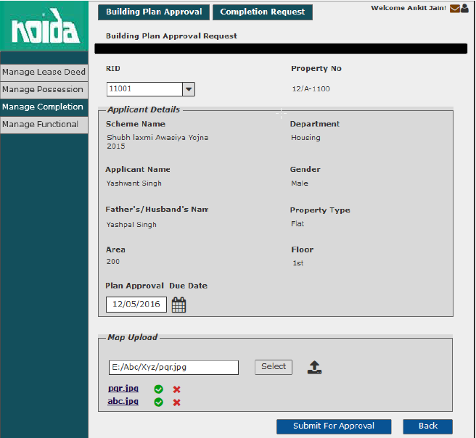

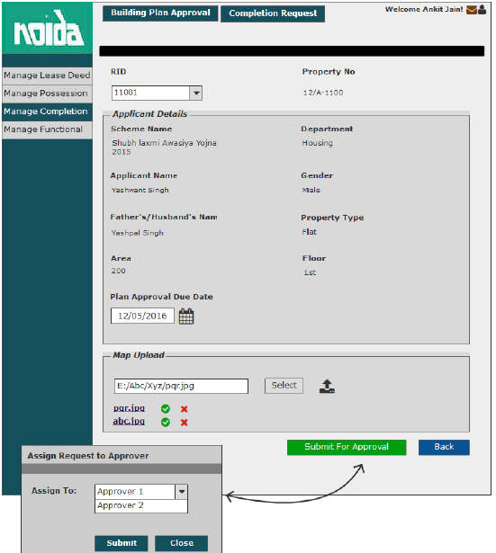

Approve/Reject Building Plan Approval Request

Sprint | 5
User Story ID | 002
User Story Title | Approve/Reject building plan approval request
Actors | Approver
Story | As an approver, I want to action building plan request of a property so that I can Approve/Reject request
Pre Conditions | - User should have required access rights.
Business Criteria | - Once a request is approved/rejected a notification would be send to initiator of the request.  - It is mandatory to provide a comment for rejecting a request.  - If a request is not actioned its status would be ‘No action’. Approved and rejected requests would have ‘approved’ and ‘rejected’ status respectively.  - If the request is cancelled by the department user, its status would be ‘cancelled’. Approver would not get any options to approve, reject.
Acceptance Criteria | - User would click on ‘Building Plan Approval Requests’ option under ‘Manage Request’ menu and get a grid which contain requests information with following columns:  - Request No  - RID  - Department  - Property Number  - Request Date  - Approved Date  - Status (pending, cancelled, approved, reject)  - User would click on the request to approve/reject and based on this selection the following information would be displayed:  - RID  - Property Number  - Scheme Name  - Department  - Applicant Name  - Gender  - Father’s/Husband Name  - Property Type  - Area  - Floor  - Plan Approval Due Date  - Maps: View  - User would view the building plan map and check for all valid condition. User would then, click on ‘Approve’ button to approve the request. Alternatively, would click on ‘Reject’ button to reject the request if conditions are not fulfilled.  - In both cases user would get a popup window to provide comment.  - In case of ‘Approve’ user would have a choice to provide comment or not however, in case of ‘Reject’ it is mandatory to provide comment.
Field level Validation

2.1 Mock-ups

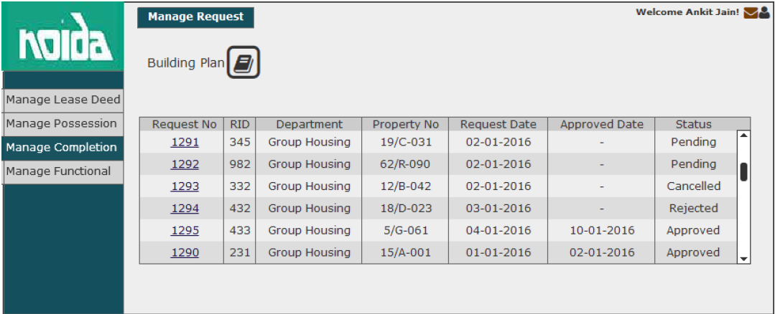
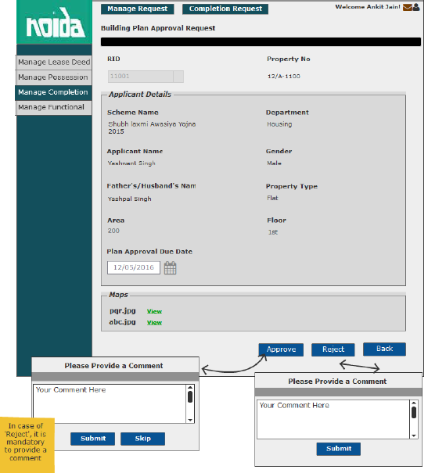
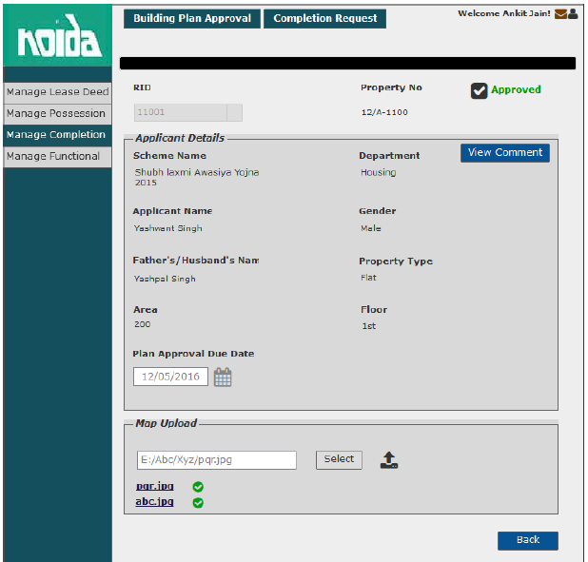

View Request- Department User

Sprint | 5
User Story ID | 003
User Story Title | View Request
Actors | Department User
Story | As an assistant, I want to view submitted building plan approval request of a property.
Pre Conditions | - User should have required access rights.
Business Criteria | - If request is submitted but not actioned by the approver then user would get ‘Cancel Request’ option only.  - If the request is rejected by the approver then user would get the option of ‘Resubmit For Approval’ and ‘View Comment’.  - For cancelled requests user would get the option to ‘resubmit Request’  - If request is approved by the approver then user would get following options:  - View Comment
Acceptance Criteria | - User would click on a particular request from the grid under manage request menu.  - User would get a screen which would display the following information:  - RID  - Property Number  - Scheme Name  - Department  - Applicant Name  - Gender  - Father’s/Husband Name  - Property Type  - Area  - Floor  - Plan Approval Due Date  - Maps: View
Field level Validation

Mock-ups

The cases covered in the Business Rules in context to “Status” are shown in the wireframe. Please refer.

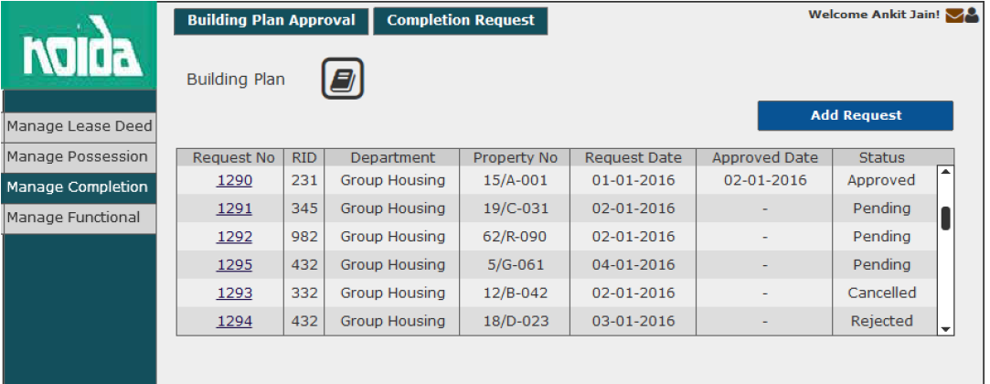
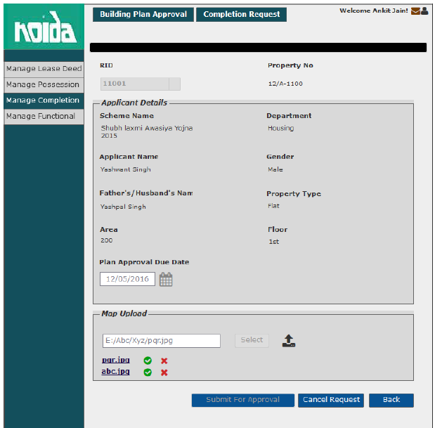

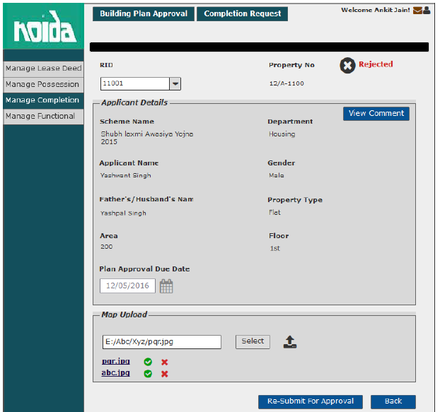
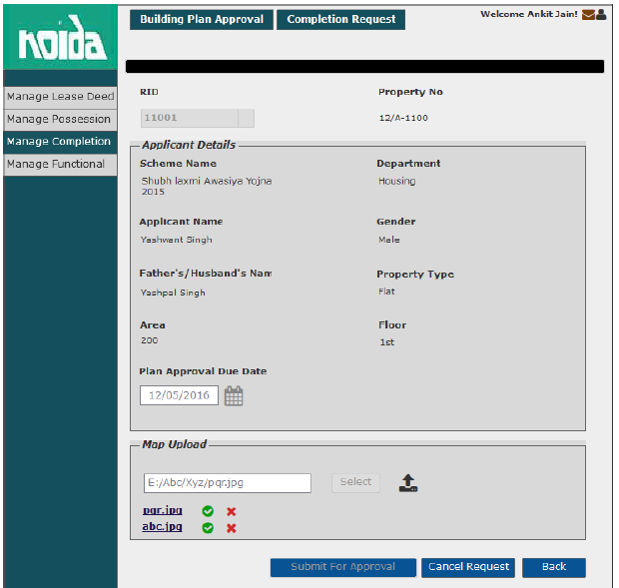

View Request- Approver

Sprint | 5
User Story ID | 004
User Story Title | View Request
Actors | Approver
Story | As an Approver, I want to view submitted building plan approval request of a property.
Pre Conditions | - User should have required access rights.
Business Criteria | - If the request is not actioned then, user would get ‘Approve’ and ‘Reject’ button.  - If request is cancelled, approved or rejected then user would not get any option.
Acceptance Criteria | - User would click on service request number from the grid under Manage Request menu  - User would get a screen which would display the following information:  - RID  - Property Number  - Scheme Name  - Department  - Applicant Name  - Gender  - Father’s/Husband Name  - Property Type  - Area  - Floor  - Plan Approval Due Date  - Maps: View RID
Field level Validation

Mock-ups

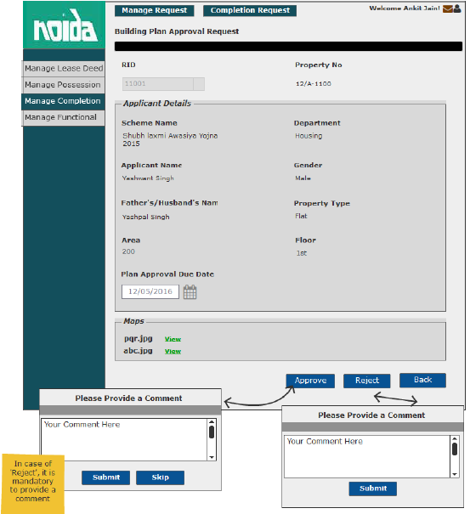

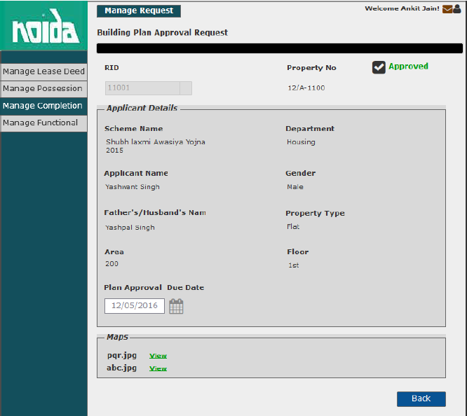
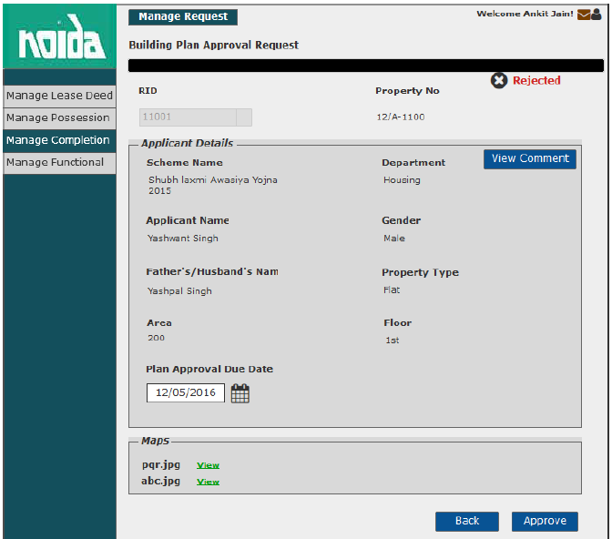

Resubmit request for building plan request

Sprint | 5
User Story ID | 005
User Story Title | Resubmit request for building plan approval.
Actors | Department User
Story | As an assistant, I want to resubmit building plan approval request for a property.
Pre Conditions | - User should have required access rights.
Business Criteria | - Only Cancelled and rejected requests would be resubmitted.  - Requested date would be updated on the grid.
Acceptance Criteria | - User would click on a particular request from the grid under manage building plan approval menu.  - Request will be displayed and user would click on the ‘Resubmit for approval’ button to request again.  - Alternatively, user would click on ‘Back’ button to return to the manage building plan page without making any changes.
Field level Validation

Mock-ups

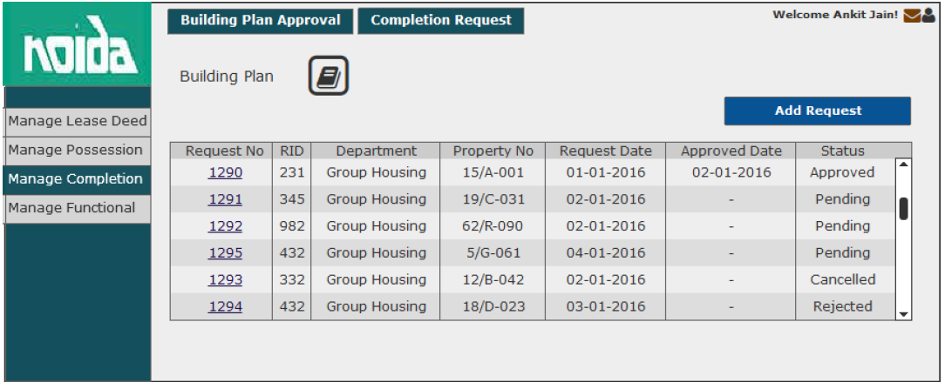
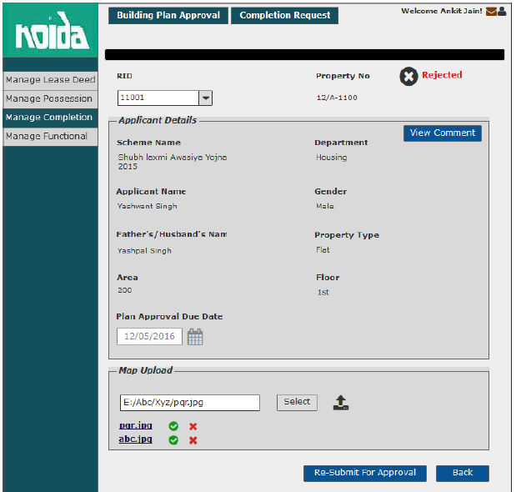

Cancel building plan approval request

Sprint | 5
User Story ID | 006
User Story Title | Cancel building plan request
Actors | Department User
Story | As an assistant, I want to cancel building plan request for a property.
Pre Conditions | - User should have required access rights.
Business Criteria | - Only those request which are pending can only be cancelled.  - The status in the building plan grid would be displayed as “Cancelled”.
Acceptance Criteria | - User would click on a particular request with status “Pending” from the grid under building plan menu.  - Request will be displayed and user would click on the ‘Cancel Request’ button to cancel the request.  - Alternatively, user would click on ‘Back’ button to return to building plan page without making any changes.
Field level Validation

Mock-ups

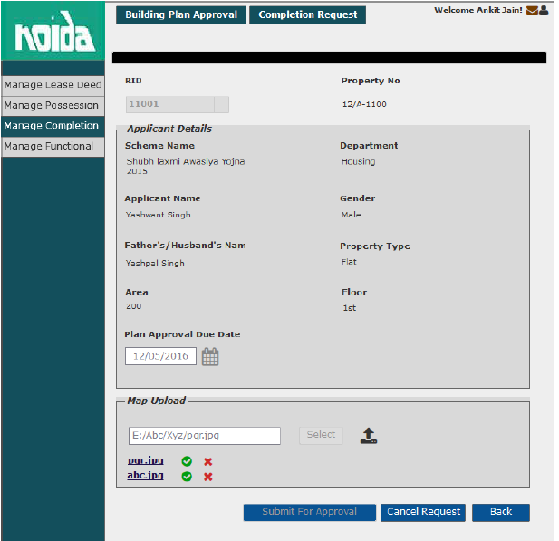

User Story- View Comment – Department user

Sprint | 5
User Story ID | 007
User Story Title | View Comment
Actors | Department user
Story | As an assistant, I want to view comment on Approved/Rejected request.
Pre Conditions | - User should have required access rights.
Business Criteria | - Only, approved/rejected request would contain the option to View comment.
Acceptance Criteria | - User would click on ‘View Comment’ button on building plan request screen.  - User would see a Popup window with the following information:  - Comment from  - Comment  - Comment Date  - If user needs to go back or cancel this screen, user would click on ‘Close’ button and the control will be directed to building plan request screen.

Mock-ups
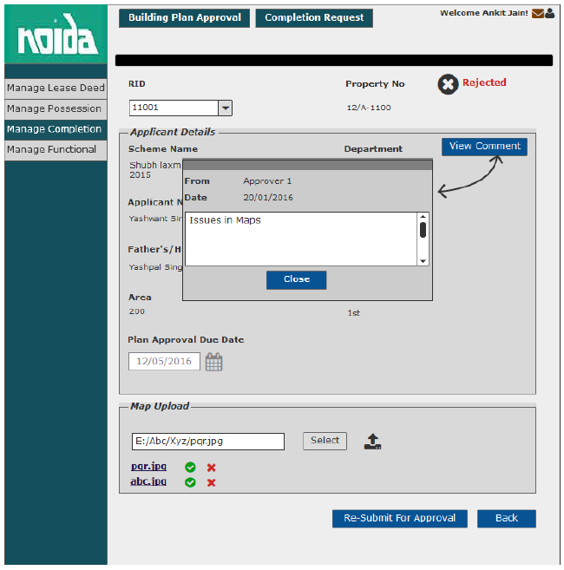

User Story- View Comment – Approver

Sprint | 5
User Story ID | 008
User Story Title | View Comment
Actors | Approver
Story | As an approver, I want to view comment on Approved/Rejected requests.
Pre Conditions | - User should have required access rights.
Business Criteria | - Only, approved/rejected request would contain the option to View comment.
Acceptance Criteria | - User would click on ‘View Comment’ button on building plan approval screen.  - User would see a Popup window with the following information:  - Comment from  - Comment  - Comment Date  - If user needs to go back or cancel this screen, user would click on ‘Close’ button and the control will be directed to building plan approval screen.

Mock-ups

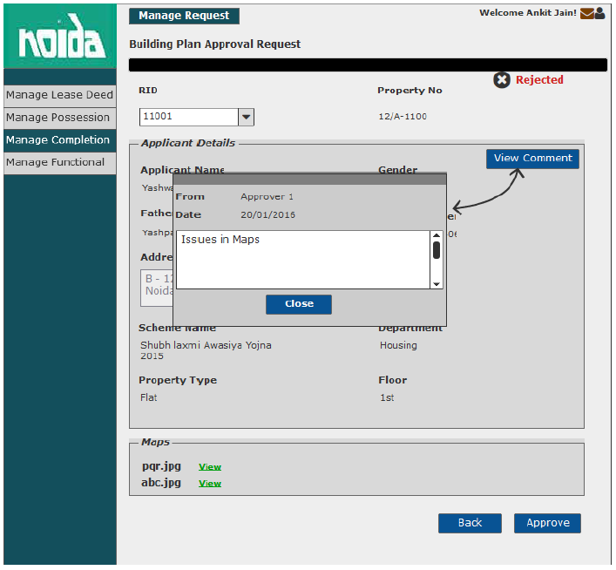

User Story- SMS/Email Notifications to allottee

Sprint | 5
User Story ID | 009
User Story Title | SMS/Email notifications to allottee
Actors | allottee
Story | As an allottee I want system to send me SMS/email notifications for building plan request
Pre Conditions | - User should have required access rights.
Business Criteria | - An SMS/Email notification would be send to allottee once; the request is submitted for building plan approval.  - An SMS/Email notification would be send to allottee once; the request is cancelled.  - An SMS/Email notification would be send to allottee once; the request is rejected with comment.  - An SMS/Email notification would be send to allottee once, the request is approved
Acceptance Criteria
Field Level Validations

Add Completion Certificate Request

Sprint | 5
User Story ID | 010
User Story Title | Add completion certificate request.
Actors | Department user
Story | As an assistant, I want to add completion certificate request of a property, so that I can generate completion certificate.
Pre Conditions | - User should have required access rights.
Business Criteria | - There would be only one request per property.  - User would be able to add completion request for his department only.  - Unique Request no. would be generated for each completion certificate request.  - An Email/SMS notification would be sent to allottee along with the request no. Notification would contain a message to collect his completion certificate and to get his/her functional letter within a time frame.  - Part completion option would be available only in case of group housing.  - Extension charges applicable if, completion done after due date.  - Completion time is given to complete the construction which  a. Counted from lease deed if possession letter issued within a year.  b. Counted from possession date if possession letter issued on or after a year.
Acceptance Criteria | Navigation: Manage Completion -> Completion Request  - User would click on ‘Add request’ button on ‘Completion Request’ screen and get a form which contain following fields:  - RID: drop down  - Based on this selection the following information would be displayed:  - Property No  - Scheme Name  - Department  - Applicant Name  - Gender  - Father/Husband Name  - Property type  - Floor (in case of Flats)  - Area  - Lease deed date  - Possession date  - Building plan approved (Yes/No)  - User needs to enter following details in completion details section:  - Completion Due Date: Date Picker, mandatory  - Completion Execution Date: Date picker, mandatory  - Completion Time From: Dropdown, mandatory  - Completion Type: Dropdown, mandatory  - Part completion (%): Textbox, mandatory in case of part completion type  - Extension: Dropdown, mandatory  - Extension Charge (INR): Textbox, mandatory in case of Extension is ‘Yes’.  - Once, user validates the information, he would click on ‘add’ button to add a completion request entry.  - Alternatively, user would click on ‘back’ button to return to completion request screen without making any changes.  - Once the request is successfully added, it would be displayed in a grid on completion request page with following columns:  - Request No  - RID  - Department  - Property No  - Completion date  - Applicant Name  - Action: Completion Certificate , Payment Challan
Field level Validation | - Part Completion (%): Decimal (5, 2), should be less than 100 and greater than 0.  - Extension Charge (INR): Decimal (12,2), should be greater than 0.

Mock-ups

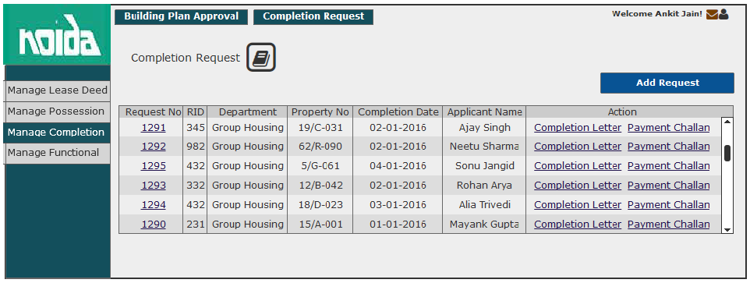
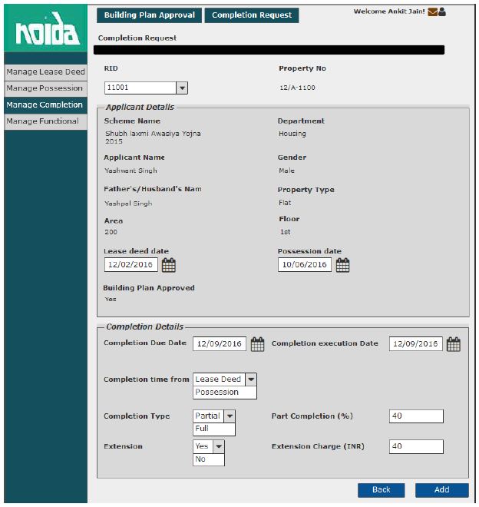

View Completion Certificate Request

Sprint | 5
User Story ID | 011
User Story Title | View completion certificate request.
Actors | Department user
Story | As an assistant, I want to view completion certificate request of a property.
Pre Conditions | - User should have required access rights.
Business Criteria
Acceptance Criteria | Navigation: Manage Completion -> Completion Request  - User would click on a particular request no from the grid on ‘Completion Request’ screen  - User would get the following fields:  - RID  - Property No  - Scheme Name  - Department  - Applicant Name  - Gender  - Father/Husband Name  - Property type  - Floor (in case of Flats)  - Area  - Lease deed date  - Possession date  - Building plan approved (Yes/No)  - Completion details section would contain the following fields:  - Completion Due Date  - Completion Execution Date  - Completion Time From  - Completion Type  - Part completion (%) (In case of part completion type)  - Extension  - Extension Charge (INR) (In case of Extension is ‘Yes’)  - To go back to completion request screen, user would click on ‘back’ button.
Field level Validation

Mock-ups

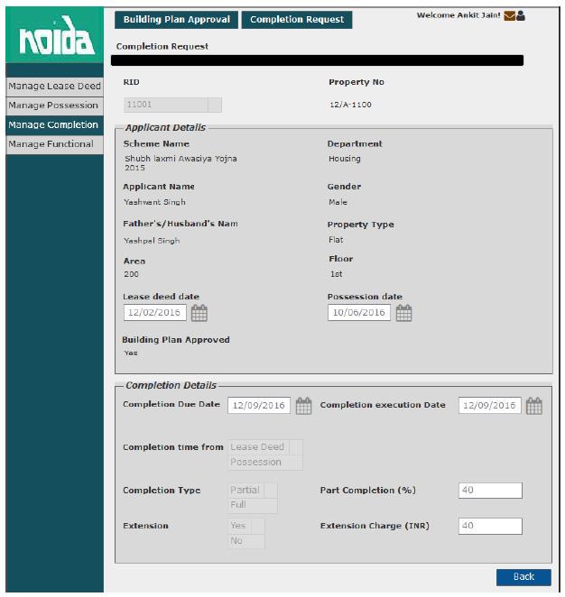

Generate Completion Certificate

Sprint | 5
User Story ID | 012
User Story Title | Generate completion Certificate
Actors | Department user
Story | As an assistant, I want to generate completion certificate of a property.
Pre Conditions | - User should have required access rights.
Business Criteria | - System would check for payment of completion fee, If not payed then, completion certificate will not be generated.
Acceptance Criteria | Navigation: Manage Completion -> Completion Request  - User would click on ‘completion certificate’ link for a particular request no from the grid on ‘Completion Request’ screen.  - Completion certificate would be displayed on a separate screen.  - User would have the options to save the file to his local system by clicking on ‘Download’ button or print completion certificate by clicking on ‘Print’ button.
Field level Validation

Mock-ups

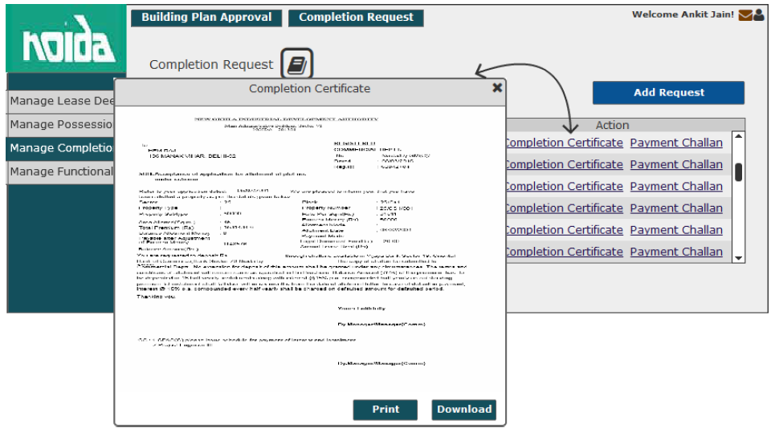

Generate Payment Challan

Sprint | 5
User Story ID | 013
User Story Title | Generate Payment Challan
Actors | Department user
Story | As an assistant, I want to generate completion certificate of a property.
Pre Conditions | - User should have required access rights.
Business Criteria | - In case of extension, payment challan would contain the extension charges along with completion fee.
Acceptance Criteria | Navigation: Manage Completion -> Completion Request  - User would click on ‘Payment Challan’ link for a particular request no from the grid on ‘Completion Request’ screen.  - Payment Challan would be displayed on a separate screen.  - User would have the options to save the file to his local system by clicking on ‘Download’ button or print payment challan by clicking on ‘Print’ button.
Field level Validation

Mock-ups

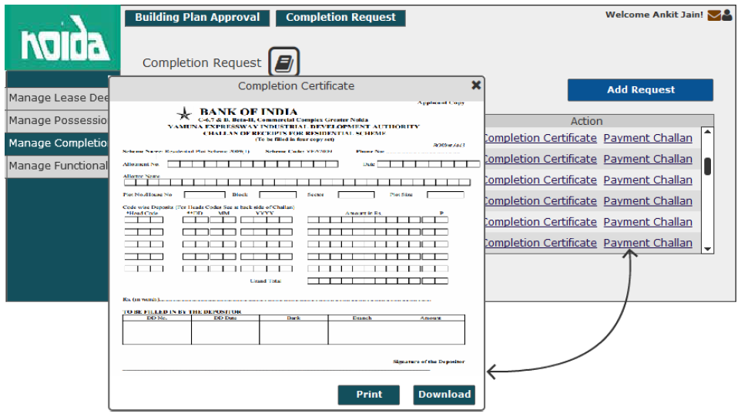

User Stories- Mortgage Permission Process

User Story- Add Mortgage Request

Sprint | 5
User Story ID | 001
User Story Title | Add Mortgage Request
Actors | Department user
Story | As an assistant, I want to request for mortgage permission of property to manager level, so that I can generate mortgage letter.
Pre Conditions | - User should have required access rights.
Business Criteria | - Unique Request no. would be generated for each mortgage request.  - Once, the request is submitted a notification would be sent to approver for the same.  - Auto notifications will be sent to approver with an interval of 3 days, if a request is in progress for approval for more than 3 days.  - An Email/SMS notification would be sent to allottee along with the request no.  - If a request is submitted to an approver but not actioned its status would be ‘In progress’. Approved and rejected requests would have ‘approved’ and ‘rejected’ status respectively.  - If the request is cancelled by the department user, its status would be ‘cancelled’.  - The request will only be approved if the property is functional and there are no dues against it.  - Mortgage permission can only be requested either before the lease deed execution or after lease deed execution.  - For the purpose of granting collateral security, processing fee would be charged as per the rule.
Acceptance Criteria | - User would click on ‘Add Mortgage Request’ option under Manage Mortgage menu and get a form which contain following fields:  - RID: drop down, mandatory  - Allottee Name: Label  - Father Name: Label  - Department: Label  - Property Type: label  - Property Number: Label  - Property Cost: Label  - Total Dues: Label  - Functional: Label  - Request Date: Date picker, mandatory  - Approval Date: Label (Once the request is approved, date would be reflected)  - Mortgage Bank Name: Text Box, mandatory  - Branch Address: Text Area, mandatory  - Mortgage Type: Dropdown, mandatory  - Processing Fee: Text Box, mandatory  - Valid Up to: Date picker, mandatory  - Previous Mortgage Bank Details: label  - Previous Loan Bank NOC: Dropdown, mandatory  - Once, user validates the information he would submit request for mortgage to manager level by clicking on ‘Submit Request for Approval’ button. User would get a popup to select approver name, user would select desired name and click on ‘Submit’ button.  - Alternatively, user would click on ‘Back’ button to return to mortgage menu without making any changes.  - After successful submission of request, it would be displayed in a grid on manage mortgage page with following columns:  - Request No  - RID  - Scheme  - Department  - Status (in progress, cancelled, approved, reject)  - Request Date  - Applicant Name  - Mortgage Purpose  - The options available in “Mortgage Purpose” dropdown are:  - Normal  - Collateral
Field level Validation | - Mortgage Bank Name: Text, maximum 100 characters  - Branch Address: Text, maximum 500 characters  - Processing fee: Numeric, Decimal (15,2)

Mock-ups

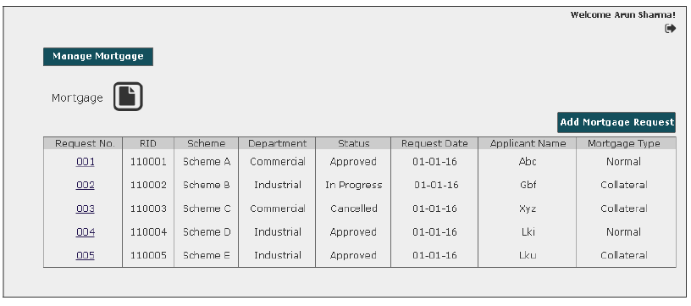

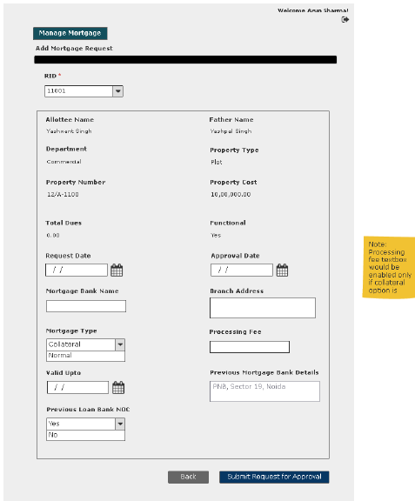

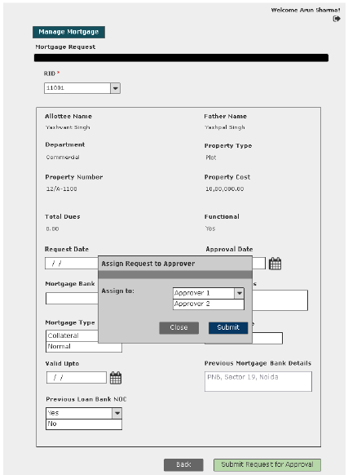

User Story- Approve/Reject Mortgage Request

Sprint | 5
User Story ID | 002
User Story Title | Approve/Reject mortgage request
Actors | Approver
Story | As an assistant, I want to action mortgage request of a property so that I can Approve/Reject request
Pre Conditions | - User should have required access rights.
Business Criteria | - Once a request is approved/rejected a notification would be send to initiator of the request.  - It is mandatory to provide a comment for rejecting a request.  - If a request is not actioned its status would be ‘No action’. Approved and rejected requests would have ‘approved’ and ‘rejected’ status respectively.  - If the request is cancelled by the department user, its status would be ‘cancelled’. Approver would not get any options to approve, reject.  - The request will only be approved if the property is functional and there are no due against it.  - Mortgage permission can only be requested either before the lease deed execution or after lease deed execution.  - For the purpose of granting collateral security, processing fee would be charged as per the rule.
Acceptance Criteria | - User would click on ‘Mortgage Request’ option under ‘Manage Request’ menu and get a grid which contain mortgage request information with following columns:  - Request No  - RID  - Scheme  - Department  - Status (in progress, cancelled, approved, reject)  - Request Date  - Applicant Name  - Mortgage Purpose  - User would click on the request to approve/reject and based on this selection the following information would be displayed:  - RID: drop down, mandatory  - Allottee Name  - Father Name  - Department  - Property Type  - Property Number  - Property Cost  - Total Dues  - Functional  - Request Date  - Approval Date  - Mortgage Bank Name  - Branch Address  - Mortgage Type  - Processing Fee  - Valid Up to  - Previous Mortgage Bank Details  - Previous Loan Bank NOC  - If user finds that the property is functional and there are no pending dues against the property. Then, user would click on ‘Approve’ button to approve the request. Alternatively, would click on ‘Reject’ button to reject the request if conditions are not fulfilled.  - In both cases user would get a popup window to provide comment.  - In case of ‘Approve’ user would have a choice to provide comment or not however, in case of ‘Reject’ it is mandatory to provide comment.
Field level Validation

2.1 Mock-ups

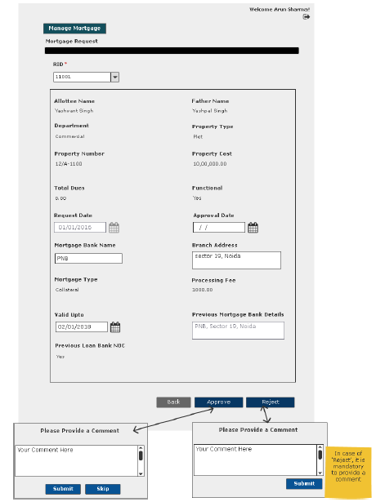

User Story- View Request- Department User

Sprint | 5
User Story ID | 003
User Story Title | View Request
Actors | Department User
Story | As an assistant, I want to view submitted mortgage request of a property.
Pre Conditions | - User should have required access rights.
Business Criteria | - If request is submitted but not actioned by the approver, then user would get ‘Cancel Request’ option only.  - If the request is rejected by the approver, then user would get the option of ‘Resubmit Request’ and ‘View Comment’.  - For cancelled requests user would get the option to ‘resubmit Request’  - If request is approved by the approver, then user would get following options:  - Generate Mortgage Letter  - View Comment
Acceptance Criteria | - User would click on a particular request from the grid under manage mortgage menu.  - User would get a screen which would display the following information:  - RID: drop down, mandatory  - Allottee Name  - Father Name  - Department  - Property Type  - Property Number  - Property Cost  - Total Dues  - Functional  - Request Date  - Approval Date  - Mortgage Bank Name  - Branch Address  - Mortgage Type  - Processing Fee  - Valid Up to  - Previous Mortgage Bank Details  - Previous Loan Bank NOC
Field level Validation

Mock-ups

The cases covered in the Business Rules in context to “Status” are shown in the wireframe. Please refer.
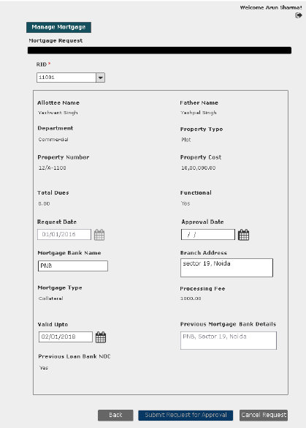
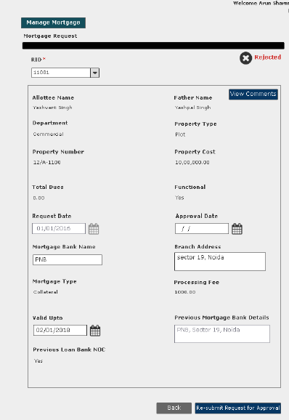
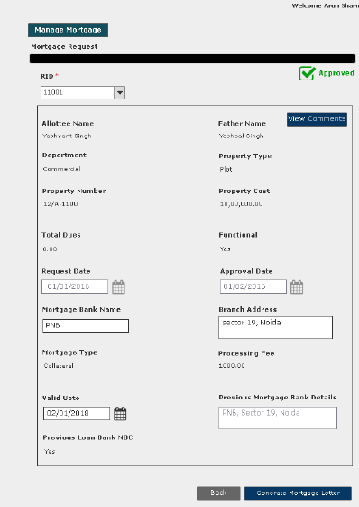

User Story- View Request- Approver

Sprint | 5
User Story ID | 004
User Story Title | View Request
Actors | Approver
Story | As an Approver, I want to view submitted mortgage request of a property.
Pre Conditions | - User should have required access rights.
Business Criteria | - If the request is not actioned then, user would get ‘Approve’ and ‘Reject’ button.  - If request is cancelled, approved or rejected then user would not get any option.
Acceptance Criteria | - User would click on approved service request number from the grid under Manage Request menu  - User would get a screen which would display the following information:  - RID: drop down, mandatory  - Allottee Name  - Father Name  - Department  - Property Type  - Property Number  - Property Cost  - Total Dues  - Functional  - Request Date  - Approval Date  - Mortgage Bank Name  - Branch Address  - Mortgage Type  - Processing Fee  - Valid Up to  - Previous Mortgage Bank Details  - Previous Loan Bank NOC  - If the request is approved, then it would also contain the “Back” Button.
Field level Validation

Mock-ups

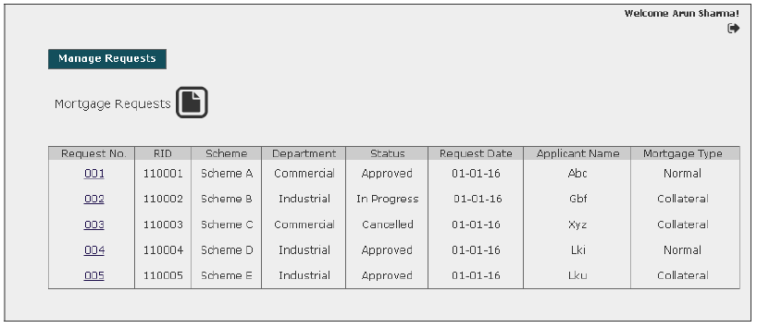
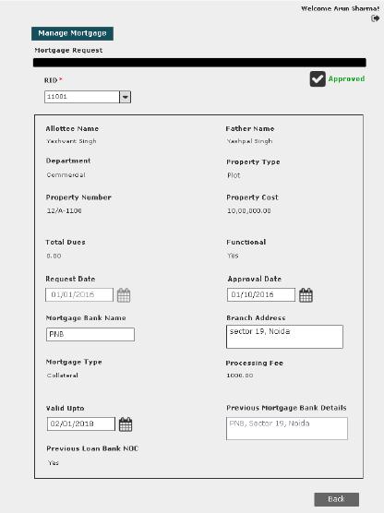

User Story- Resubmit request for mortgage request

Sprint | 5
User Story ID | 005
User Story Title | Resubmit request for mortgage permission
Actors | Department User
Story | As an assistant, I want to resubmit mortgage request of a property.
Pre Conditions | - User should have required access rights.
Business Criteria | - Only Cancelled and rejected requests would be resubmitted.  - Requested date would be updated on the grid.
Acceptance Criteria | - User would click on a particular request from the grid under manage mortgage menu.  - Request will be displayed and user would click on the ‘Resubmit’ button to request again.  - Alternatively, user would click on ‘Back’ button to return to the manage mortgage page without making any changes.
Field level Validation

Mock-ups

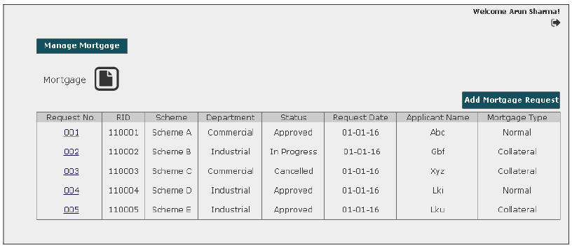

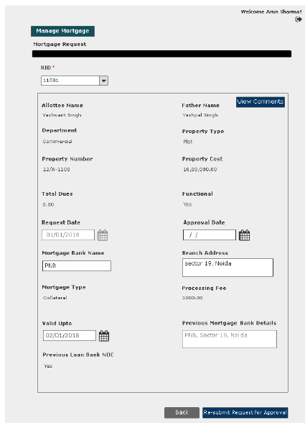

User Story- Cancel mortgage request

Sprint | 5
User Story ID | 006
User Story Title | Cancel mortgage request
Actors | Department User
Story | As an assistant, I want to cancel mortgage request of a property.
Pre Conditions | - User should have required access rights.
Business Criteria | - Only those request which are in progress would be cancelled.  - The status in the manage mortgage grid would be displayed as “Cancelled”.
Acceptance Criteria | - User would click on a particular request with status “In Progress” from the grid under manage mortgage menu.  - Request will be displayed and user would click on the ‘Cancel Request’ button to cancel the request.  - Alternatively, user would click on ‘Back’ button to return to the manage mortgage page without making any changes.
Field level Validation

Mock-ups

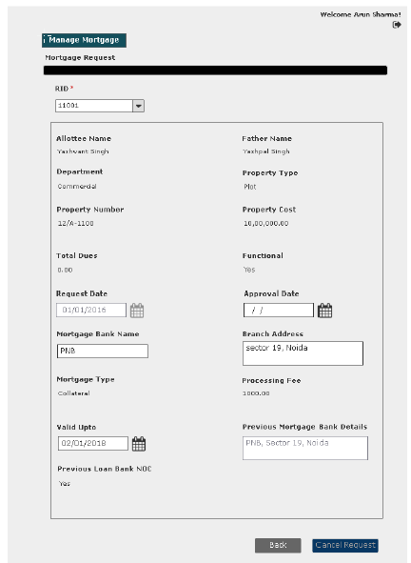

User Story- View Comment (Requestor)

Sprint | 5
User Story ID | 007
User Story Title | View Comment
Actors | Department user
Story | As an assistant, I want to view comment on Approve/Rejected mortgage request
Pre Conditions | - User should have required access rights.
Business Criteria | - Only, approved/rejected request would contain the option to View comment.
Acceptance Criteria | - User would click on ‘View Comment’ button on approved/rejected mortgage request screen.  - User would see a Popup window with the following information:  - Comment from  - Comment  - Comment Date  - If user wishes to go back or close this screen, user would click on ‘Back’ button and would be redirected to manage mortgage screen.

Mock-ups

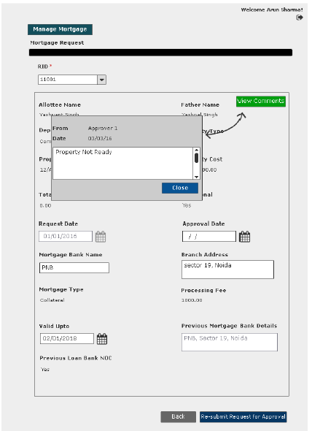

User Story- View Comment (Approver)

Sprint | 5
User Story ID | 008
User Story Title | View Comment
Actors | Approver
Story | As an approver, I want to view comment on Approve/Rejected mortgage request
Pre Conditions | - User should have required access rights.
Business Criteria | - Only, approved/rejected request would contain the option to View comment.
Acceptance Criteria | - User would click on ‘View Comment’ button on approved/rejected mortgage request screen.  - User would see a Popup window with the following information:  - Comment from  - Comment  - Comment Date  - If user wishes to go back or close this screen, user would click on ‘Back’ button and would be redirected to manage mortgage screen.

Mock-ups
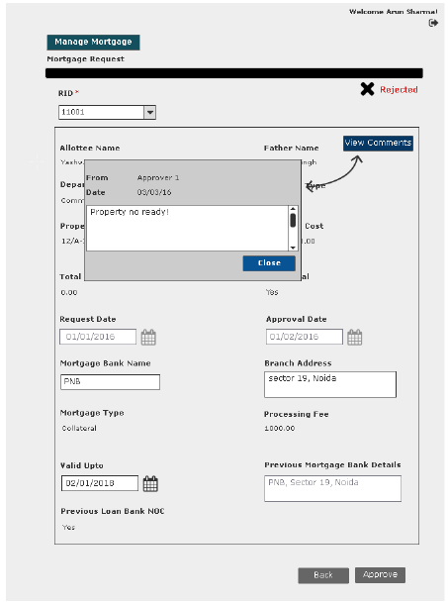

User Story- Generate Mortgage Letter

Sprint | 5
User Story ID | 009
User Story Title | Generate Mortgage Letter
Actors | Department user
Story | As an assistant, I want to generate mortgage letter.
Pre Conditions | - User should have required access rights.
Business Criteria | - Only, approved request would contain the option to generate mortgage letter.  - System would check for payment of processing fee in case of collateral mortgage. If not payed then, mortgage letter will not be generated and system would ask the user to pay the charge.
Acceptance Criteria | - User would click on ‘Generate Mortgage’ button on mortgage request screen.  - Mortgage letter would be displayed on a separate screen.  - User would have the options to save the file to his local system by clicking on ‘Download’ button or print mortgage letter by clicking on ‘Print’ button.
Field Level Validations

Mock-ups
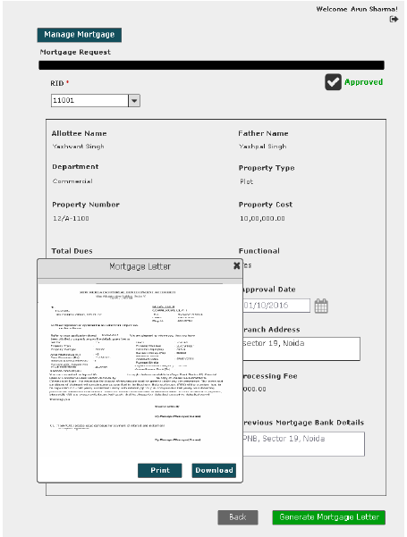

User Story- SMS/Email Notifications to allottee

Sprint | 5
User Story ID | 010
User Story Title | SMS/Email notifications to allottee
Actors | allottee
Story | As an allottee I want system to send me SMS/email notifications for mortgage request
Pre Conditions | - User should have required access rights.
Business Criteria | - An SMS/Email notification would be send to allottee once; the request is submitted for mortgage.  - An SMS/Email notification would be send to allottee once; the request is cancelled.  - An SMS/Email notification would be send to allottee once; the request is rejected with comment.  - An SMS/Email notification would be send to allottee once, the request is approved
Acceptance Criteria
Field Level Validations

User Stories- Rent Permission Process

User Story- Add Rent Permission

Sprint | 5
User Story ID | 001
User Story Title | Add Rent Request
Actors | Department user
Story | As a department user, I want to request for rent permission of property to manager level, so that I can generate rent permission letter.
Pre Conditions | - User should have required access rights.
Business Criteria | - There would be only one request per property.  - Unique Request no. would be generated for each rent permission request.  - Once, the request is submitted a notification would be sent to approver for the same.  - Auto notifications will be sent to approver with an interval of 3 days, if a request is in progress for approval for more than 3 days.  - An Email/SMS notification would be sent to allottee along with the request no.  - If a request is submitted to an approver but not actioned its status would be ‘In progress’. Approved and rejected requests would have ‘approved’ and ‘rejected’ status respectively.  - If the request is cancelled by the department user, its status would be ‘cancelled’.  - The request will only be approved if the property is functional and there are no due against it.  - Rent permission is granted if:  i. Upto date dues of authority have been cleared.  ii. Lease deed/Transfer deed/Sale deed as applicable has been executed.
Acceptance Criteria | - User would click on ‘Add Rent Request’ option under Rent Permission menu and get a form which contain following fields:  - RID: drop down, mandatory  - Department: Label  - Allottee Name: Label  - Sector: Label  - Block: Label  - Property Number: Label  - Total Dues: Label  - Functional Status: Label  - Request Date: Date picker, mandatory  - Tenant Name: Text Box, mandatory  - Tenant Project: Text Box, mandatory  - Property Type: Dropdown, mandatory  - Rent Duration: Dropdown, mandatory  - Renting Charge: Text Box, mandatory  - Renting Date: Date picker, mandatory  - Once, user validates the information he would submit request for rent permission to manager level by clicking on ‘Submit Request’ button. User would get a popup to select approver name, user would select desired name and click on ‘Submit’ button.  - Alternatively, user would click on ‘Back’ button to return to rent permission menu without making any changes.  - After successful submission of request, it would be displayed in a grid on rent permission page with following columns:  - Request No  - RID  - Scheme  - Department  - Request Date  - Applicant Name  - Tenant Name  - Status (in progress, cancelled, approved, reject)  - User has an option to search on the rent permission screen. User selects scheme and department from the dropdown available, then clicks on search button to view details as per selection criteria on the grid.  - The options available in “Property Type” dropdown are from Property type table in database.  - The options available in “Rent Duration” dropdown are:  - 5 Years  - 10 Years  - Figures will populate as per table in database
Field level Validation | - Tenant Name: Text, maximum 100 characters  - Tenant Project: Text, maximum 200 characters

Mock-ups

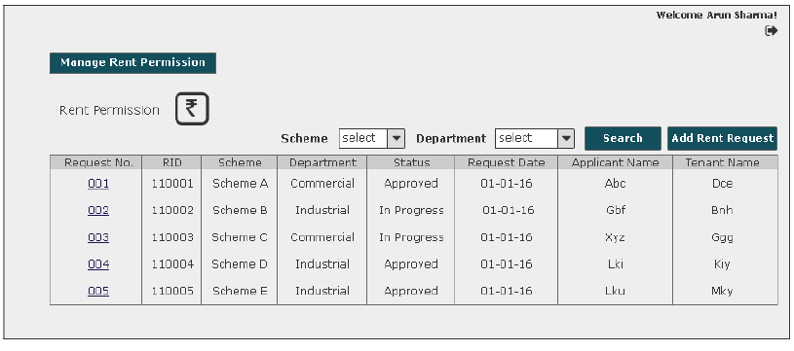
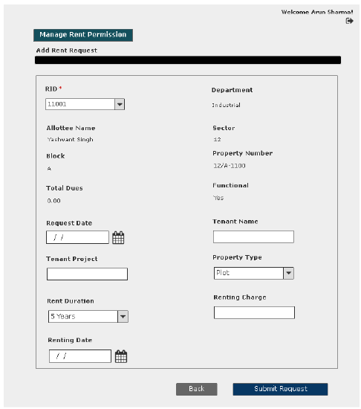
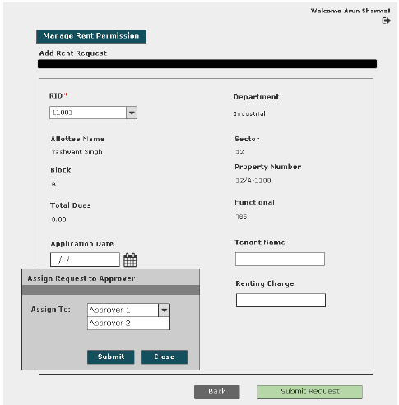

User Story- Approve/Reject Rent Request

Sprint | 5
User Story ID | 002
User Story Title | Approve/Reject rent permission request
Actors | Approver
Story | As an approver, I want to action rent request of a property so that I can Approve/Reject request
Pre Conditions | - User should have required access rights.
Business Criteria | - Once a request is approved/rejected a notification would be send to initiator of the request.  - It is mandatory to provide a comment for rejecting a request.  - If a request is not actioned its status would be ‘No action’. Approved and rejected requests would have ‘approved’ and ‘rejected’ status respectively.  - If the request is cancelled by the department user, its status would be ‘cancelled’. Approver would not get any options to approve, reject.  - The request will only be approved if the property is functional and there are no due against it.  - Rent permission is granted if:  i. Upto date dues of authority have been cleared.  ii. Lease deed/Transfer deed/Sale deed as applicable has been executed.
Acceptance Criteria | - User would click on ‘Rent Requests’ option under ‘Manage Request’ menu and get a grid which contain rent requests information with following columns:  - Request No  - RID  - Scheme  - Department  - Request Date  - Applicant Name  - Tenant Namee  - Status (in progress, cancelled, approved, reject)  - User would click on the request to approve/reject and based on this selection the following information would be displayed:  - RID: drop down  - Department  - Scheme  - Allottee Name  - Property Number  - Total Dues  - Functional Status  - Request Date  - Tenant Name  - Tenant Project  - Rent Duration  - Property Type  - Renting Charge  - Renting Date  - If user finds that the property is functional and there are no pending dues against the property. Then, user would click on ‘Approve’ button to approve the request. Alternatively, would click on ‘Reject’ button to reject the request if conditions are not fulfilled.  - In both cases user would get a popup window to provide comment.  - In case of ‘Approve’ user would have a choice to provide comment or not however, in case of ‘Reject’ it is mandatory to provide comment.  - User has an option to search on the “Manage Request” screen. User selects scheme and department from the dropdown available, then clicks on search button to view details as per selection criteria on the grid.
Field level Validation | - Comment: Text, maximum 500 characters, mandatory in case of reject list.

2.1 Mock-ups

User Story- View Request- Department User

Sprint | 5
User Story ID | 003
User Story Title | View Request
Actors | Department User
Story | As a department user, I want to view submitted rent permission request of a property.
Pre Conditions | - User should have required access rights.
Business Criteria | - If request is submitted but not actioned by the approver then user would get ‘Cancel Request’ option only.  - If the request is rejected by the approver then user would get the option of ‘Resubmit Request’ and ‘View Comment’.  - For cancelled requests user would get the option to ‘resubmit Request’  - If request is approved by the approver then user would get following options:  - Generate Rent Permission Letter  - View Comment
Acceptance Criteria | - User would click on a particular request from the grid under manage request menu.  - User would get a screen which would display the following information:  - RID: drop down  - Department  - Allottee Name  - Sector  - Block  - Property Number  - Total Dues  - Functional Status  - Request Date  - Tenant Name  - Tenant Project  - Property Type  - Rent Duration  - Renting Charge  - Renting Date
Field level Validation

Mock-ups

The cases covered in the Business Rules in context to “Status” are shown in the wireframe. Please refer.
Submitted for approval
Request is submitted but not actioned by the approver

Cancelled/Rejected
Approved

User Story- View Request- Approver

Sprint | 5
User Story ID | 004
User Story Title | View Request
Actors | Approver
Story | As an Approver, I want to view submitted rent request of a property.
Pre Conditions | - User should have required access rights.
Business Criteria | - If the request is not actioned then, user would get ‘Approve’ and ‘Reject’ button.  - If request is cancelled, approved or rejected then user would not get any option.
Acceptance Criteria | - User would click on approved service request number from the grid under Manage Request menu  - User would get a screen which would display the following information:  - RID: drop down  - Department  - Scheme  - Allottee Name  - Property Number  - Total Dues  - Functional Status  - Request Date  - Tenant Name  - Tenant Project  - Rent Duration  - Property Type  - Renting Charge  - Renting Date  - If the request is approved then it would also contain the “Back” Button.
Field level Validation

Mock-ups

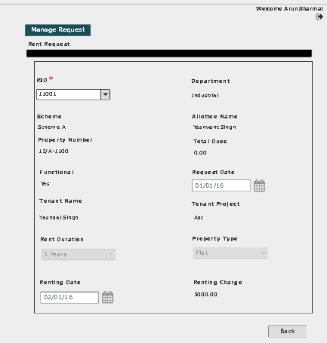

User Story- Resubmit request for rent request

Sprint | 5
User Story ID | 005
User Story Title | Resubmit request for rent permission
Actors | Department User
Story | As a department user, I want to resubmit rent request of a property.
Pre Conditions | - User should have required access rights.
Business Criteria | - Only Cancelled and rejected requests would be resubmitted.  - Requested date would be updated on the grid.
Acceptance Criteria | - User would click on a particular request from the grid under manage rent permission menu.  - Request will be displayed and user would click on the ‘Resubmit’ button to request again.  - Alternatively, user would click on ‘Back’ button to return to the manage rent permission page without making any changes.
Field level Validation

Mock-ups

User Story- Cancel rent permission request

Sprint | 5
User Story ID | 006
User Story Title | Cancel rent permission request
Actors | Department User
Story | As a department user, I want to cancel rent request of a property.
Pre Conditions | - User should have required access rights.
Business Criteria | - Only those request which are in progress would be cancelled.  - The status in the manage rent permission grid would be displayed as “Cancelled”.
Acceptance Criteria | - User would click on a particular request with status “In Progress” from the grid under manage rent permission menu.  - Request will be displayed and user would click on the ‘Cancel Request’ button to cancel the request.  - Alternatively, user would click on ‘Back’ button to return to the manage rent permission page without making any changes.
Field level Validation

Mock-ups

User Story- View Comment (Requestor)

Sprint | 5
User Story ID | 007
User Story Title | View Comment
Actors | Department user
Story | As a department user, I want to view comment on Approve/Rejected rent request
Pre Conditions | - User should have required access rights.
Business Criteria | - Only, approved/rejected request would contain the option to View comment.
Acceptance Criteria | - User would click on ‘View Comment’ button on rent permission screen.  - User would see a Popup window with the following information:  - Comment from  - Comment  - Comment Date  - If user wishes to go back or close this screen, user would click on ‘Back’ button and would be redirected to rent permission screen.

Mock-ups

User Story- View Comment (Approver)

Sprint | 5
User Story ID | 008
User Story Title | View Comment
Actors | Approver
Story | As an approver, I want to view comment on Approve/Rejected mortgage request
Pre Conditions | - User should have required access rights.
Business Criteria | - Only, approved/rejected request would contain the option to View comment.
Acceptance Criteria | - User would click on ‘View Comment’ button on approved/rejected mortgage request screen.  - User would see a Popup window with the following information:  - Comment from  - Comment  - Comment Date  - If user wishes to go back or close this screen, user would click on ‘Back’ button and would be redirected to manage mortgage screen.

Mock-ups

User Story- Generate Rent Permission Letter

Sprint | 5
User Story ID | 009
User Story Title | Generate Rent Permission Letter
Actors | Department user
Story | As a department user, I want to generate rent permission letter.
Pre Conditions | - User should have required access rights.
Business Criteria | - Only, approved request would contain the option to generate rent permission letter.  - System would check for payment of rent permission charge. If not payed then, rent permission letter will not be generated and system would ask the user to pay the charge.
Acceptance Criteria | - User would click on ‘Generate Rent Permission’ button on rent request screen.  - Rent permission letter would be displayed on a separate screen.  - User would have the options to save the file to his local system by clicking on ‘Save’ button or print rent permission letter by clicking on ‘Print’ button.
Field Level Validations

Mock-ups

User Story- Generate Payment challan- Rent Permission Charge
Sprint | 5
User Story ID | 010
User Story Title | Generate Payment challan- Rent Permission Charge
Actors | Department user
Story | As a department user, I want to generate payment challan for rent permission charge.
Pre Conditions | - User should have required access rights.
Business Criteria | - Only, approved request would contain the option to generate payment challan.  - Formula of Rent Permission Charge:  Rent Permission charge = (FAR * Defined Amount) * N  FAR = Floor Area Ratio  Defined Amount = Area-wise amount set by the authority  N = number of years
Acceptance Criteria | - User would click on ‘Payment challan’ button on rent permission request screen.  - Rent charge payment challan would be displayed on a separate screen.  - User would have the options to save the file to his local system by clicking on ‘Save’ button or print payment challan by clicking on ‘Print’ button.
Field Level Validations

Mock-ups

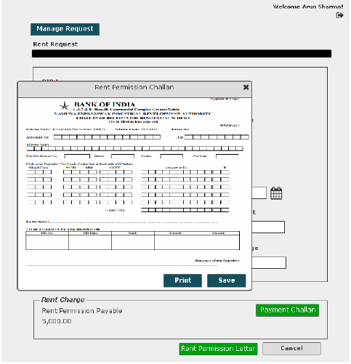

User Story- SMS/Email Notifications to allottee

Sprint | 5
User Story ID | 011
User Story Title | SMS/Email notifications to allottee
Actors | allottee
Story | As an allottee I want system to send me SMS/email notifications for rent permission request
Pre Conditions | - User should have required access rights.
Business Criteria | - An SMS/Email notification would be send to allottee once; the request is submitted for rent permission.  - An SMS/Email notification would be send to allottee once; the request is cancelled.  - An SMS/Email notification would be send to allottee once; the request is rejected with comment.  - An SMS/Email notification would be send to allottee once, the request is approved
Acceptance Criteria
Field Level Validations

User Stories- Functional Process

User Story- Request Functional Approval

Sprint | 5
User Story ID | 001
User Story Title | Request Functional Approval
Actors | Department user
Story | As a department user, I want to request for approval of a functional property, so that I can generate Functional certificate.
Pre Conditions | - User should have required access rights.
Business Criteria | - Functional request would be submitted for completed properties only (properties, to which completion certificate has been issued. Alternatively, properties which are marked completed or partially completed)  - User would only be able submit functional request for his department.  - In case of property is transferred, its previous functional status would be null and void and a re-functional approval is required.  - Once, the request is submitted a notification would be sent to approver for the same.  - Auto notifications will be sent to approver with an interval of 3 days, if a request is in progress for approval for more than 3 days.  - If a request is submitted to an approver but not actioned its status would be ‘pending’. Approved and rejected requests would have ‘approved’ and ‘rejected’ status respectively.  - If the request is cancelled by the department user, its status would be ‘cancelled’.
Acceptance Criteria | Navigation-> Manage Functional Properties -> Request functional  - User would get a form which contain following fields:  - RID: drop down  - Based on this selection the following information would be displayed:  - Property No.  - Scheme Name  - Department  - Applicant Name  - Gender  - Father/Husband Name  - Property type  - Area  - Floor (in case of flats)  - Functional Due Date ( to be filled)  - User would enter the Functional due date.  - User would check the documents submitted (checkbox).  - Meter sealing certificate by UPSEB  - Affidavit  - Registration Certificate of trade tax dept.  - NDC from Accounts  - Once, user validates the information he would submit request for by clicking on ‘Submit Request’ button.  - User would be given an option to choose the approver. User would select the approver name from the drop down and click ‘Submit’ button to submit the request.  - Alternatively, user would click on ‘back’ button to return to manage functional menu without making any changes.  - After successful submission of request it would be displayed in a grid on manage functional properties page with following columns:  - Request No  - RID  - Property No  - Request date  - Approved date (for approved entries)  - Status (Pending, cancelled, approved, rejected)
Field level Validation

Mock-ups
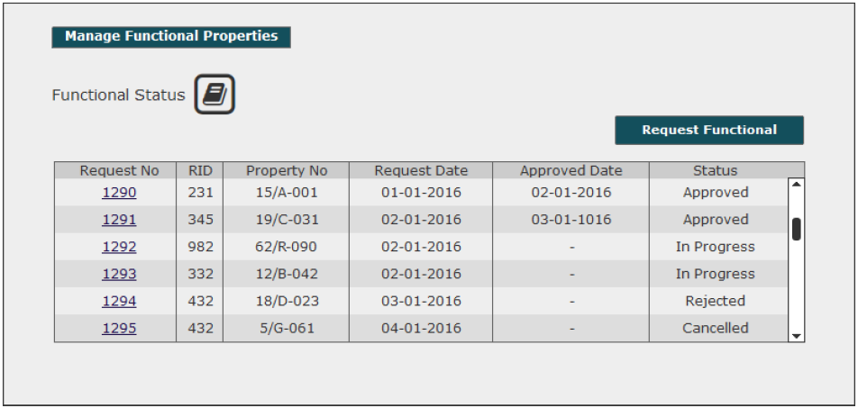
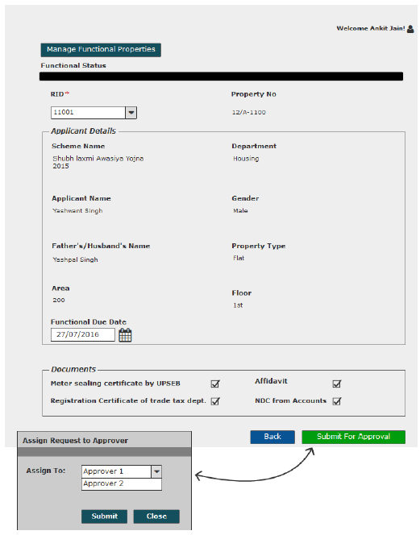

View Request- Department User

Sprint | 5
User Story ID | 002
User Story Title | View Request
Actors | Department User
Story | As a department user, I want to view submitted functional request of a property.
Pre Conditions | - User should have required access rights.
Business Criteria | - If request is submitted but not actioned by the approver then user would get ‘Cancel Request’ and ‘back’ button.  - If the request is rejected by the approver then user would get the option of ‘Resubmit Request’ and ‘View Comment’ along with ‘ack’ button  - For cancelled requests user would get the option to ‘resubmit Request’ and ‘Back’ button.  - If request is approved by the approver then user would get following options:  - Functional Charge Challan  - Generate Functional Certificate  - View Comment  - Back
Acceptance Criteria | - User would click on a particular request no from the grid under manage functional properties menu  - User would get a screen which would display the following information:  - RID  - Scheme Name  - Department  - Property No  - Applicant Name  - Father/Husband Name  - Property type  - Area  - Floor (In case of Housing properties)  - Functional due date  - Functional date (for approved entry)  - User would get documents details.  - User would get different options based on the scenario( see Business Rules)
Field level Validation

Mock-ups

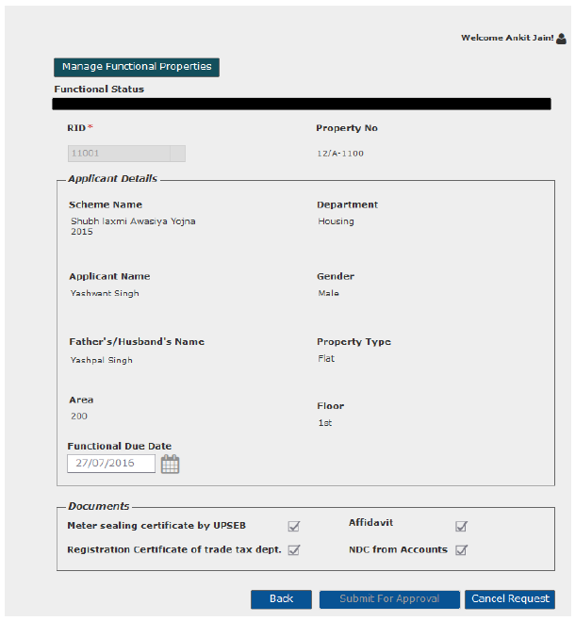
Request submitted for approval
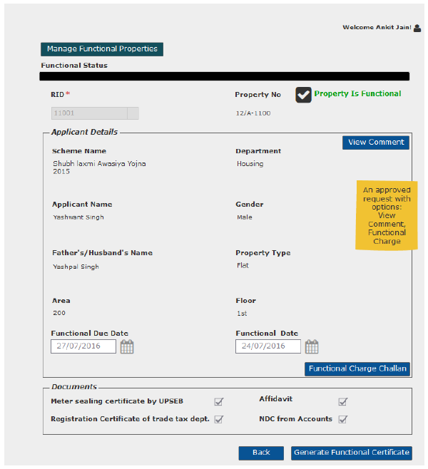
Approved Functional Request
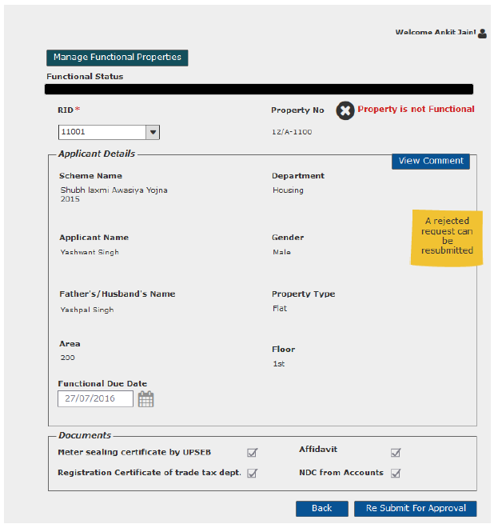
Rejected Functional request

Cancel Functional Approval request

Sprint | 5
User Story ID | 003
User Story Title | Cancel functional approval request
Actors | Department User
Story | As a department user, I want to cancel functional approval request of a property.
Pre Conditions | - User should have required access rights.
Business Criteria | - Only those request which are in progress would be cancelled.
Acceptance Criteria | - User would click on a particular request from the grid under manage functional properties menu.  - Request will be displayed and user would click on the ‘Cancel Request’ button to cancel the request.  - Alternatively, user would click on ‘Back’ button to return to the manage Functional page without making any changes.
Field level Validation

Mock-ups

View Comment- Department User

Sprint | 5
User Story ID | 004
User Story Title | View Comment
Actors | Department user
Story | As a department user, I want to view comment on functional request
Pre Conditions | - User should have required access rights.
Business Criteria | - Only, approved/rejected request would contain the option to View comment.
Acceptance Criteria | Navigation: Manage Functional Properties -> Functional Request -> View Comment  - User would click on ‘View Comment’ button on functional request screen.  - User would see a Popup window with the following information:  - Comment from  - Comment  - Comment Date  - If user needs to go back or cancel this screen, user would click on ‘Close’ button and the control will be directed to Functional order request screen.
Field Level Validation

Mock-ups
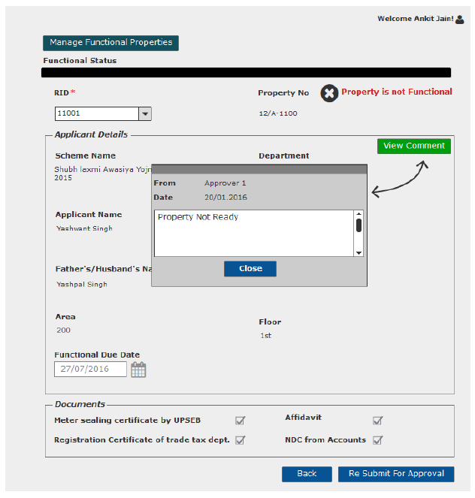

View Request- Approver

Sprint | 5
User Story ID | 005
User Story Title | View Request
Actors | Approver
Story | As an approver, I want to view submitted functional approval request of a property.
Pre Conditions | - User should have required access rights.
Business Criteria | - If the request is not actioned then, user would get ‘Approve’ and ‘Reject’ button along with ‘back’ button.  - If request is cancelled then, user would get ‘back’ button.  - If request is approved then, user would get ‘View Comment’ and ‘back’ button.  - If request is rejected then, user would get ‘View comment’, ‘Approve’ and ‘back’ button.
Acceptance Criteria | - User would click on ‘Functional Request’ under ‘Manage request’ menu and get a grid which contain functional requests information with following columns:  - Request No  - RID  - Property No  - Request Date  - Approved Date  - Status (Pending/Approved/Rejected/Cancelled)  - User would click on a particular request from the grid under Manage Request menu  - User would get a screen which would display the following information:  - Property Functional Status  - RID  - Scheme Name  - Department  - Property No  - Applicant Name  - Father/Husband Name  - Property type  - Area  - Floor (In case of flats)  - Functional due date  - Functional date (for approved entries)  - User would get documents detail.  - User would get different options based on the scenario( see Business Rules)
Field level Validation

Mock-ups

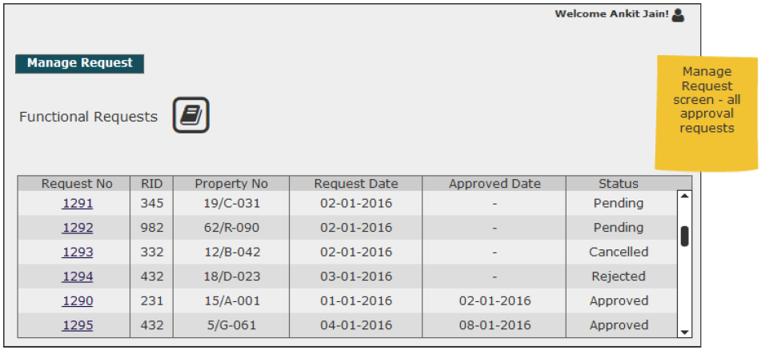
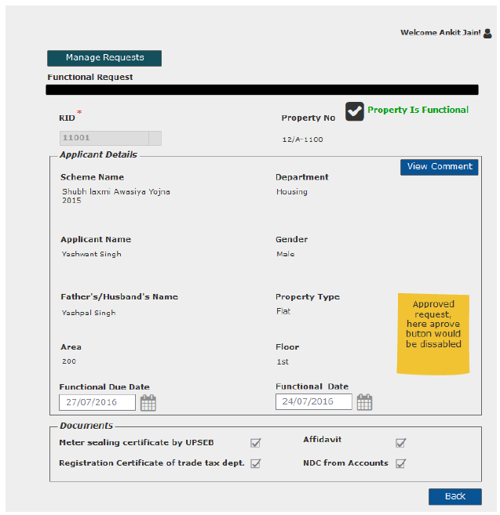
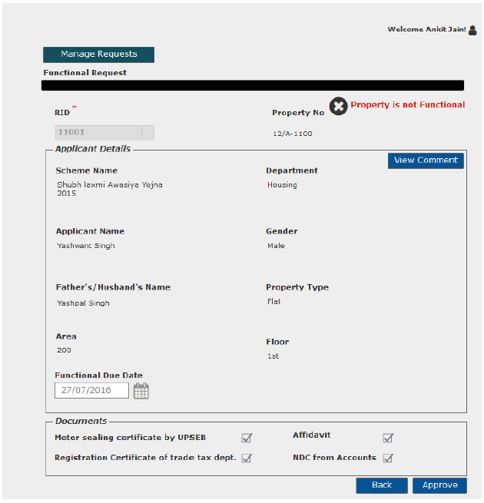

User Story- Approve/Reject Functional approval Request

Sprint | 6
User Story ID | 006
User Story Title | Approve/Reject Functional Approval request
Actors | Approver
Story | As an approver, I want to action functional request of a property so that I can Approve/Reject request.
Pre Conditions | - User should have required access rights.
Business Criteria | - Once a request is approved/rejected a notification would be send to initiator of the request.  - Once the request is approved property is marked functional, approval date is functional date.  - It is mandatory to provide a comment for rejecting a request.  - Rejected request can be approved again.  - It is mandatory to provide a comment when approving an already rejected request.  - If a request is not actioned its status would be ‘pending’. Approved and rejected requests would have ‘approved’ and ‘rejected’ status respectively.  - If the request is cancelled by the department user, its status would be ‘cancelled’. Approver would not get any options to approve, reject or change area for these requests.  - Requests with ‘Pending’ as Status column would always be displayed on top.
Acceptance Criteria | - User would click on ‘Functional Request’ under ‘Manage request’ menu and get a grid which contain functional requests information with following columns:  - Request No  - RID  - Property No  - Request Date  - Approved Date  - Status (Pending/Approved/Rejected/Cancelled)  - User would click on a particular request from the grid under Manage Request menu  - User would get a screen which would display the following information:  - Property Functional Status  - RID  - Scheme Name  - Department  - Property No  - Applicant Name  - Father/Husband Name  - Property type  - Area  - Floor (In case of flats)  - Functional Due Date  - User would get documents detail which are submitted by allottee.  - Meter sealing certificate by UPSEB  - Affidavit  - Registration Certificate of trade tax dept.  - NDC from Accounts  - Under User would click on ‘Approve’ button to approve the request or ‘Reject’ button to reject the request.  - In both cases user would get a popup window to provide comment.  - In case of ‘Approve’ user would have a choice to provide comment or not however, in case of ‘Reject’ it is mandatory to provide comment.
Field level Validation | - Comment: Text, maximum 500 characters, mandatory in case of reject list.

Mock-ups

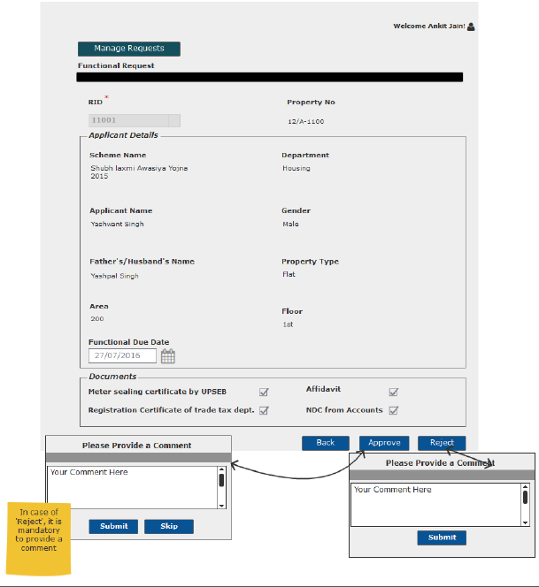

Resubmit request for Functional Approval

Sprint | 5
User Story ID | 007
User Story Title | Resubmit request for Functional Approval
Actors | Department User
Story | As a department user, I want to resubmit functional approval request of a property.
Pre Conditions | - User should have required access rights.
Business Criteria | - Only Cancelled and rejected requests would be resubmitted.  - Requested date would be updated on the grid.
Acceptance Criteria | - User would click on a particular request from the grid under ‘Manage Functional Properties’ menu.  - Request will be displayed and user would click on the ‘Resubmit for Approval’ button to request again.  - Alternatively, user would click on ‘Back’ button to return to the manage Functional page without making any changes.
Field level Validation

Mock-ups
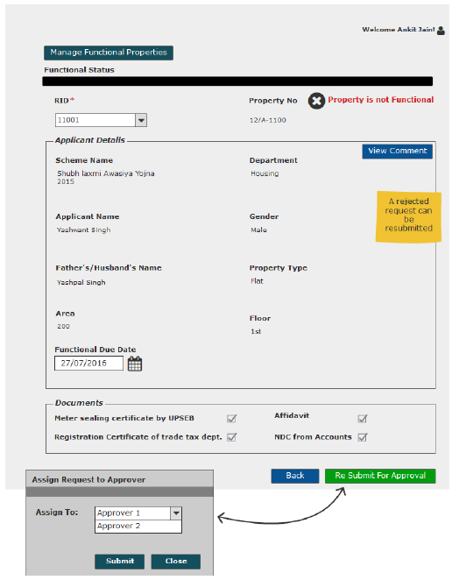

View Comment- Approver

Sprint | 5
User Story ID | 008
User Story Title | View Comment
Actors | Department user
Story | As a department user, I want to view comment on functional request
Pre Conditions | - User should have required access rights.
Business Criteria | - Only, approved/rejected request would contain the option to View comment.
Acceptance Criteria | Navigation: Manage Request -> Functional Request -> View Comment  - User would click on ‘View Comment’ button on functional request screen.  - User would see a Popup window with the following information:  - Comment from  - Comment  - Comment Date  - If user needs to go back or cancel this screen, user would click on ‘Close’ button and the control will be directed to Functional order request screen.
Field Level Validation

Mock-ups

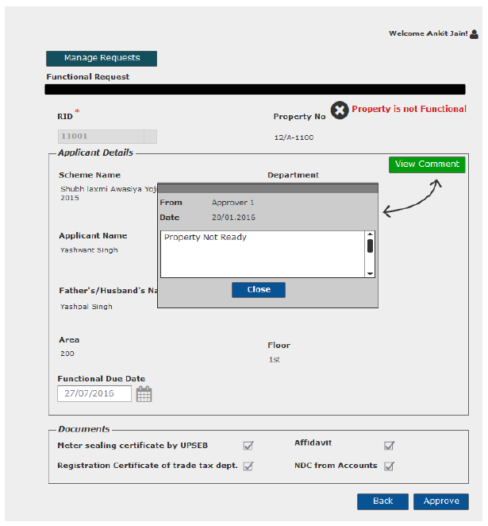

Generate Functional Certificate

Sprint | 5
User Story ID | 009
User Story Title | Generate Functional Certificate
Actors | Department user
Story | As a department user, I want to generate functional Certificate
Pre Conditions | - User should have required access rights.
Business Criteria | - Only, approved request would contain the option to generate functional certificate.  - System would check for payment of functional charge, If not payed then, functional certificate will not be generated.
Acceptance Criteria | - User would click on ‘Generate Functional Certificate’ button on functional request screen.  - Functional certificate would be displayed on a separate screen.  - User would have the options to save the file to his local system by clicking on ‘download’ button or print functional Certificate by clicking on ‘Print’ button.
Field Level Validations

Mock-ups
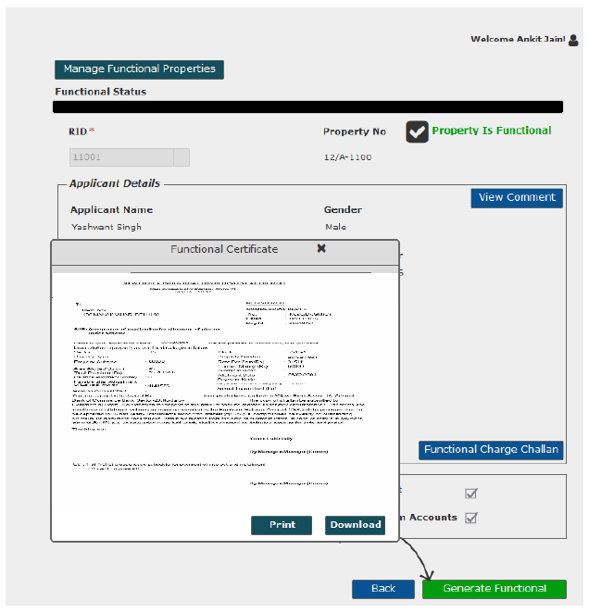

Generate Functional Charge challan

Sprint | 6
User Story ID | 011
User Story Title | Generate Functional Charge Challan
Actors | Department user
Story | As a department user, I want to generate payment challan for functional charge.
Pre Conditions | - User should have required access rights.
Business Criteria | - Only approved functional properties would contain the option to generate payment challan for functional charge.  - Payment Challan would be generated only if there are no dues till date.
Acceptance Criteria | - User would click on ‘Functional Charge Challan’ button on functional request screen.  - Challan would be displayed on a separate screen.  - User would have the options to save the file to his local system by clicking on ‘download’ button or print challan by clicking on ‘Print’ button.
Field Level Validations

Mock-ups

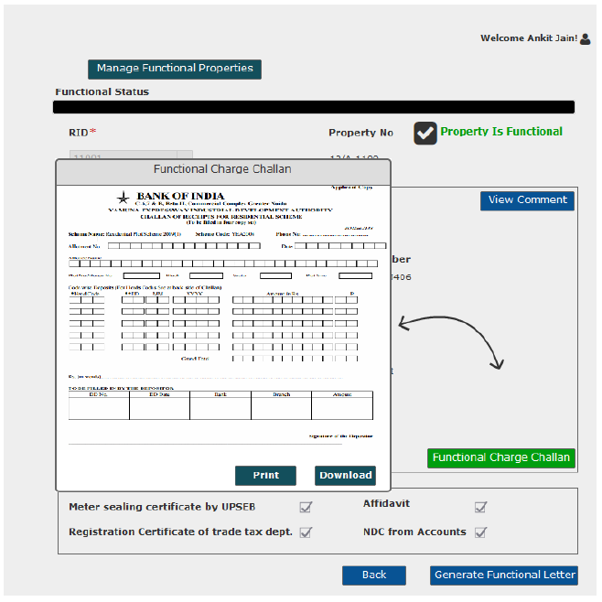

SMS/Email Notifications to allottee

Sprint | 5
User Story ID | 011
User Story Title | SMS/Email notifications to allottee
Actors | allottee
Story | As an allottee I want system to send me SMS/email notifications for Functional request
Pre Conditions | - User should have required access rights.
Business Criteria | - An SMS/Email notification would be send to allottee once, the request is submitted for Functional Status.  - An SMS/Email notification, in case of property status not functional.  - An SMS/Email notification, in case of property status functional:  - An SMS/Email notification would be send to allottee, if the request is cancelled.  - An SMS/Email notification would be send to allottee, if the request is rejected with comment.  - An SMS/Email notification would be send to allottee, if the request is approved, asking user to clear any dues in order to get functional letter and to pay functional charge.  - Once functional charge is paid, notification to user to get his functional Certificate
Acceptance Criteria
Field Level Validations

